Talent
People practices driving business results

New North Workplace Excellence Award
An award of the Attract, Develop and Retain Diverse Talent Committee of New North

Application Phase 1 - Submission Form

Sponsored by:
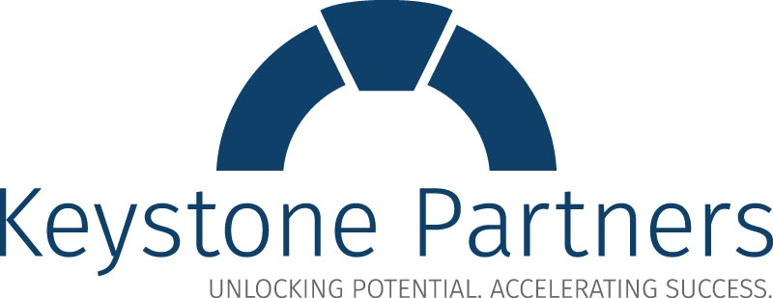

2023-24 New North Workplace Excellence Award
The New North Workplace Excellence Award, a collaboration between New North and Keystone Partners, recognizes organizations that are improving their competitive advantage through people practices that lead to successful business outcomes.

Eligibility
Organizations located within the 18-county New North region are eligible to apply. This includes companies that have a division or location within the New North but are not necessarily headquartered in the New North.

The 18 counties include: Brown, Calumet, Door, Florence, Fond du Lac, Green Lake, Kewaunee, Manitowoc, Marinette, Marquette, Menominee, Oconto, Outagamie, Shawano, Sheboygan, Waupaca, Waushara, and Winnebago.

People Practices* |  | Business Practices*
- Orientation & Assimilation |  | - Savings
- Recruitment, Selection & Retention |  | - Financial
- Culture Management |  | - Efficiencies
- Alignment & Engagement |  | - Growth
- Development/Performance Management |  | - Financial
- Employee Communication |  | - Customers
- Succession/Knowledge Transfer |  | - Increased Profitability
- Exit (Retirement or Outplacement)
*Including, but not limited to these areas

The New North Workplace Excellence Award application process consists of three phases:

Phase 1 Organizations complete brief statement of consideration (500 words or less).
Phase 2 Organizations meeting Phase 1 requirements will be notified and invited to submit a detailed application.
Phase 3 Organizations meeting Phase 2 requirements will become finalists and a site visit will be conducted by members of the judges committee to select winner(s).

Important Dates and Information*

Oct 6th 2023 Phase 1 responses due by 5:00PM CDT. Responses should be emailed to lsmith@keystonepartners.com

Oct 27th 2023 Organizations moving onto Phase 2 will be notified.

Jan 26th 2024 Phase 2 applications due by 5:00PM CDT. Responses should be emailed to lsmith@keystonepartners.com

Feb 16th 2024 Phase 3 finalists notified and site visits are scheduled during March and early April 2024.

*Additional information and key dates will be shared with organizations reaching Phase 2 and 3 of the process.

Background Information
Organization name:
Application completed by (Name & Title):
Contact person (Name & Title, if different from above):
Contact person phone:
Contact person email:
Business address (in the New North region)
Address 1:
Address 2:
City, State, Zip:
Headquarters address (if different)
Address 1:
Address 2:
City, State, Zip:
How did you hear about this award:
Type of Ownership: Public Private Other, specify:
Industry:

Number of employees at your location(s) in the New North region:
Year organization was founded:
Chief executive or highest-ranking senior manager within the New North:
Briefly describe your organization and scope of services and/or products (4 or 5 sentences):

Brief Statement of Consideration

Please describe, in 500 words or less, the people practice(s) utilized by your organization that led to successful and sustained business outcomes.

