Gold Shovel Ready Sites Submission Instructions

To submit a property for inclusion in the Gold Shovel Ready Sites Program, please follow the below steps. Note that there are no submission deadlines. Applications can be submitted at any time throughout the year.

- Notify New North of your interest in the program – barb.lamue@thenewnorth.com

- New North will establish a Drop Box to place information.

- Complete the attached submission form and gather the requested documentation. Please make sure that your submittal is complete and organized before loading it to the Dropbox. If possible, provide the submittal form and all documentation as one digital folder. No hard copy documents will be accepted. Identify the county where the property is located, as this will determine which RPC will be reviewing the documentation.

- When submittal is ready, submit payment to:
New North, Inc.
2740 W. Mason Street
Green Bay, WI 54303

Payable to the respective RPC

- Information is reviewed for completeness by New North and the respective RPC. You will be notified of any information that needs to be submitted. You will also be notified once your submittal is approved.

- Questions regarding the certification process can be directed to Barb LaMue, President & CEO of New North, Inc. at (920) 676-1960 (cell) or barb.lamue@thenewnorth.com, or, Manny Vasquez, Vice President, Business Development, NAI Pfefferle & Pfefferle Companies at (920) 858-1075 or MannyV@naipfefferle.com.

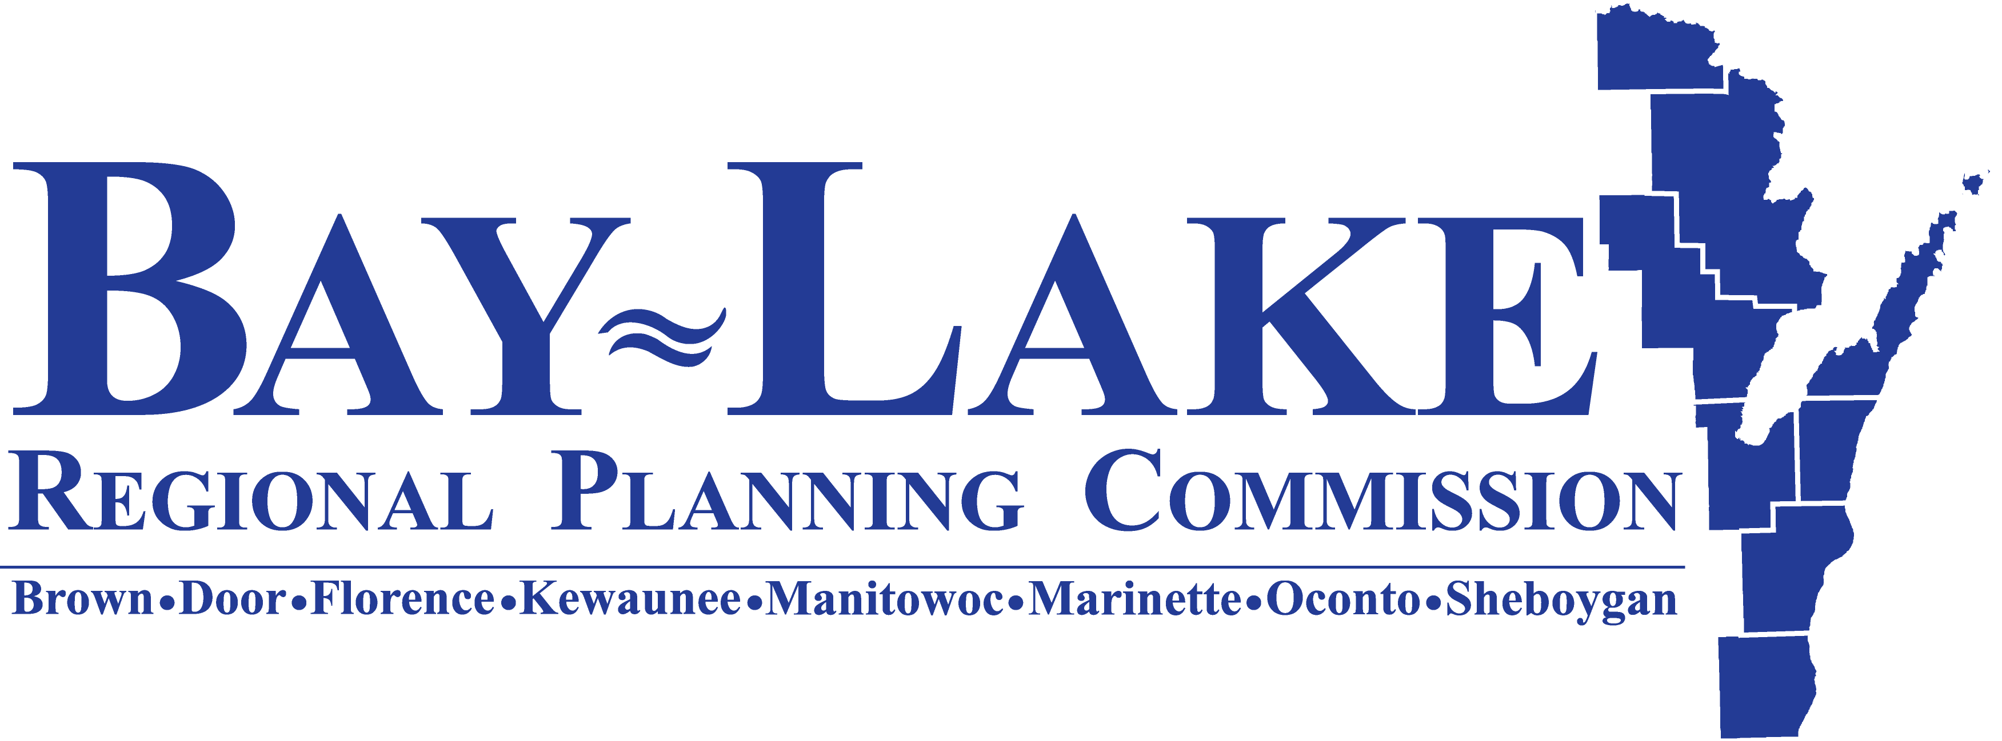
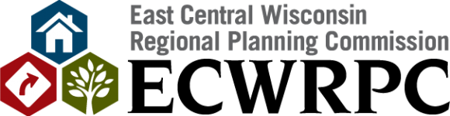

Nicole Barbiaux Adam Pfefferle
nbarbiaux@Baylakerpc.org apfefferle@ecwrpc.org
920-448-2820 Ext. 104 920-751-4770
http://www.baylakerpc.org/ http://www.ecwrpc.org/

Bay-Lake RPC ECWRPC
Brown Calumet
Door Fond du Lac
Florence Green Lake
Kewaunee Marquette
Manitowoc Menominee
Marinette Outagamie
Oconto Shawano
Sheboygan Waupaca
Waushara
Winnebago

- Once approved, your property will be entered in the State of Wisconsin’s Locate in Wisconsin property database, flagged as being Gold Shovel Ready on the New North website and marketed as a Gold Shovel Ready Site.

- If at any point you would like modifications made to your property information please contact New North. Changes made to the files after initial approval may include a fee of $150.00.

