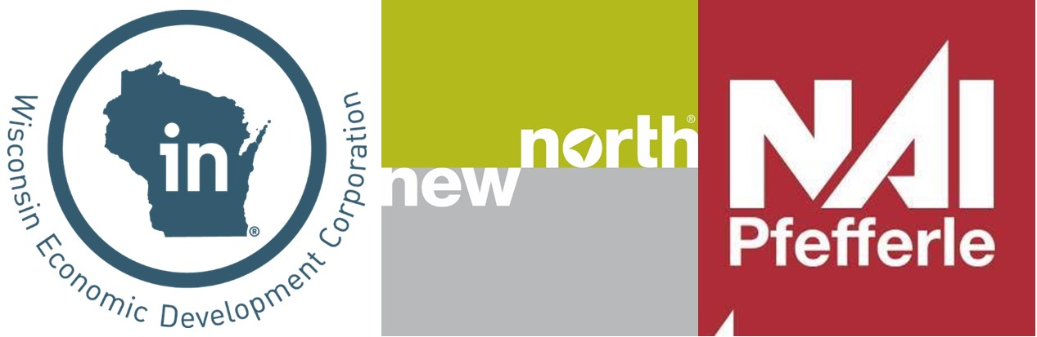

**How will this be promoted?**

Through this program, sites are promoted directly to developers and real estate professionals. Designated sites are automatically entered into the State of Wisconsin’s online property database and are featured on New North’s website. Advertising campaigns, newsletters, direct marketing, and other communication efforts throughout the year promote Gold Shovel sites to real estate brokers and site selectors.

**How long does the designation last?**

New North’s Gold Shovel Ready Site designation is valid for one year. At the end of year one, the information is validated or updated.

[**www.thenewnorth.com**](http://www.thenewnorth.com)

**How do I apply?**

Visit <https://www.thenewnorth.com/gold-site-certification/> for the full   
list of criteria and submission instructions.

**What is it?**

The New North Gold Shovel Ready Site designation is designed to identify both publicly and privately owned sites throughout the New North region, which are suitable for development. The goal of this program is to gather uniform site information to increase the quality of site documentation, as well as the overall number of sites that are ready for development. New North actively markets these sites to regional, national and international site selectors.

**Gold Shovel Ready Sites have:**

* Current Maps
* Utilities installed or near enough for a prompt installation
* Appropriate transportation routes
* Zoning in place or planned
* Documentation of any nearby restrictions   
  (geological, environmental, easements)
* Willing sellers and clear ownership information
* Area statistics and demographic information

**Why should you participate?**

The Gold Shovel designation identifies your property to developers, site selectors and companies looking for suitable expansion locations. Knowing this information up front helps brokers, site selectors, developers and companies expedite their search, allowing these particular sites to stand out against the competition. With a partnership with NAI Pfefferle, their team will help with the application process.

**How does this differ from the state of Wisconsin certified sites program?**

This designation does not replace or compete with the State of Wisconsin Certified Site Program, but rather provides an alternative for smaller sites or those that cannot meet the criteria of the State program. New North markets the Wisconsin Certified Sites within the region at no charge as part of the Gold Shovel Ready marketing.

**Is there a cost to participate?**

Yes, the cost to apply is $500 per listing or for contiguous parcels. One business park is considered to be one listing even though it may include several contiguous development lots.

**Select Gold Shovel Ready.**

Your contact info goes here.